Chapter 19, Problem 91.

For the transistor network of Fig.19.130,

h_{fe} = 80, h_{ie} = 1.2 kΩ

h_{re} = 1.5 × 10⁻⁴, h_{oe} = 20 μ S

Determine the following:
- voltage gain A_{v} = V_{o}/V_{s},
- current gain A_{i} = I_{o}/I_{i},
- input impedance Z_{in},
- output impedance Z_{out}.

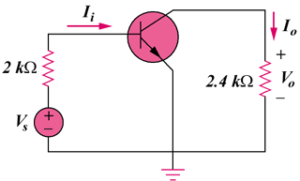
Figure 19.130
For Prob. 19.91.

